For the account dashboard

1. HTML Structure
<header>
<h1>Accountant Dashboard - Hospital</h1>
</header>
This is the header of the dashboard.
It displays the dashboard title.

<div class="cards">
<div class="card" id="revenueCard">
<h3>Total Revenue 💰</h3>
<span id="totalRevenue">₦1,200,000</span>
</div>
<div class="card" id="expensesCard">
<h3>Total Expenses 💸</h3>
<span id="totalExpenses">₦850,000</span>
</div>
<div class="card" id="pendingCard">
<h3>Pending Payments 📂</h3>
<span id="pendingPayments">₦120,000</span>
</div>
</div>

These cards summarize the key numbers:
Total Revenue
Total Expenses
Pending Payments
Each card has an id so the JavaScript can update it dynamically.
Later, the. highlight animation is used when numbers change.

<div class="container">
<h2>Add Transaction</h2>
<form id="transactionForm">
<input type="text" id="patientName" placeholder="Patient Name" required>
<select id="transactionType" required>
<option value="Payment">Payment</option>
<option value="Expense">Expense</option>
</select>
<input type="number" id="transactionAmount" placeholder="Amount" required>
<input type="date" id="transactionDate" required>
<select id="transactionStatus" required>
<option value="Paid">Paid</option>
<option value="Unpaid">Unpaid</option>
</select>
<button type="submit">Add Transaction</button>
</form>

<table id="transactionTable">
<thead>
<tr>
<th>ID</th>
<th>Patient Name</th>
<th>Type</th>
<th data-sort="amount">Amount</th>
<th data-sort="date">Date</th>
<th>Status</th>
<th>Actions</th>
</tr>
</thead>
<tbody id="transactionBody"></tbody>
</table>
</div>
Form: Lets you add new transactions.
Patient name, type (Payment/Expense), amount, date, and status (Paid/Unpaid).
Table: Displays all transactions.
body is empty at first; rows are added dynamically via JavaScript.
data-sort attributes on headers allow click-to-sort by amount or date.

2. CSS Styling
Basic Layout & Cards
.cards { display: flex; gap: 1rem; margin: 1rem; }
.card { flex: 1; padding: 1rem; border-radius: 8px; text-align: center; }
.card.highlight { animation: highlightCard 0.8s ease; }
@keyframes highlightCard { 0% { background-color: #ffff99; transform: scale(1.05); } 100% { background-color: yellowgreen; transform: scale(1); } }
Cards are displayed in a row (flex).
.highlight animation makes the card flash yellow and slightly grow when updated.
Table Styles
table { width: 100%; border-collapse: collapse; margin-top: 1rem; }
th, td { padding: 0.75rem; border: 1px solid #ccc; text-align: center; }
th { background-color: #f1f1f1; cursor: pointer; }
.unpaid { background-color: #ffe5e5; color: #a00; animation: unpaidFlash 1s ease-in-out; }
th headers are clickable for sorting.
.unpaid rows flash red to highlight unpaid transactions.

3. JavaScript Functionality
a) DOM References
const revenueSpan = document.getElementById('totalRevenue');
const expensesSpan = document.getElementById('totalExpenses');
const pendingSpan = document.getElementById('pendingPayments');
const revenueCard = document.getElementById('revenueCard');
const expensesCard = document.getElementById('expensesCard');
const pendingCard = document.getElementById('pendingCard');
const form = document.getElementById('transactionForm');
const tableBody = document.getElementById('transactionBody');
These are references to elements so JS can read/write values and apply animations.

b) Utility Functions
function parseCurrency(str) { return parseInt(str.replace(/₦|,/g, '')) || 0; }
function formatCurrency(num) { return `₦${num.toLocaleString()}`; }
parseCurrency → Converts a string like ₦1,200 to 1200.
formatCurrency → Formats numbers to currency with ₦ and commas.
function animateCard(card) {
card.classList.add('highlight');
setTimeout(() => card.classList.remove('highlight'), 800);
}
Adds highlight animation to a card when values change.

c) Updating Pending Payments
function updatePendingPayments() {
let totalPending = 0;
[...tableBody.rows].forEach(row => {
if (row.cells[5].textContent === "Unpaid") totalPending += parseCurrency(row.cells[3].textContent);
});
pendingSpan.textContent = formatCurrency(totalPending);
animateCard(pendingCard);
}
Loops through all rows in the table.
Checks status column; sums up unpaid amounts.
Updates the Pending Payments card dynamically.

d) Local Storage
function saveData() {
const transactions = [...tableBody.rows].map(row => ({
name: row.cells[1].textContent,
type: row.cells[2].textContent,
amount: parseCurrency(row.cells[3].textContent),
date: row.cells[4].textContent,
status: row.cells[5].textContent
}));

localStorage.setItem('dashboardData', JSON.stringify({
transactions,
totalRevenue: parseCurrency(revenueSpan.textContent),
totalExpenses: parseCurrency(expensesSpan.textContent)
}));
}
Saves transactions and totals in browser memory (localStorage).
Data persists even after page refresh.
window.onload = function() {
const savedData = JSON.parse(localStorage.getItem('dashboardData')) || {
transactions: [],
totalRevenue: 1200000,
totalExpenses: 850000
};
revenueSpan.textContent = formatCurrency(savedData.totalRevenue);
expensesSpan.textContent = formatCurrency(savedData.totalExpenses);
savedData.transactions.forEach(tr => addTransactionRow(tr.name, tr.type, tr.amount, tr.date, tr.status));
updatePendingPayments();
};
When the page loads:
Retrieve saved data.
Populate table with previous transactions.
Update totals.

e) Adding a Transaction
form.addEventListener('submit', function(e) {
e.preventDefault();
const name = document.getElementById('patientName').value;
const type = document.getElementById('transactionType').value;
const amount = parseInt(document.getElementById('transactionAmount').value);
const date = document.getElementById('transactionDate').value;
const status = document.getElementById('transactionStatus').value;

addTransactionRow(name, type, amount, date, status);

if (type === "Payment") { revenueSpan.textContent = formatCurrency(parseCurrency(revenueSpan.textContent) + amount); animateCard(revenueCard);}
else { expensesSpan.textContent = formatCurrency(parseCurrency(expensesSpan.textContent) + amount); animateCard(expensesCard); }

updatePendingPayments();
saveData();
form.reset();
});
Prevent form default to stop page reload.
Read form values.
Add row to table.
Update revenue/expenses/pending totals.
Animate updated cards.
Save to localStorage.
Reset form fields.

f) Edit & Delete Functions
Edit
Change cells to <input> or <select> to modify values.
Adjust totals based on old vs new amounts.
Update pending payments and save data.
Delete
Remove row from table.
Update totals and pending payments.
Save data.

g) Table Sorting
document.querySelectorAll('th[data-sort]').forEach(th => {
th.addEventListener('click', () => {
const type = th.dataset.sort;
const rows = [...tableBody.rows];
rows.sort((a, b) => {
if (type === 'amount') return parseCurrency(b.cells[3].textContent) - parseCurrency(a.cells[3].textContent);
else if (type === 'date') return new Date(b.cells[4].textContent) - new Date(a.cells[4].textContent);
});
tableBody.innerHTML = '';
rows.forEach(r => tableBody.appendChild(r));
recalcIDs();
});
});
Clicking the Amount or Date headers sorts the table.
Updates row IDs after sorting.
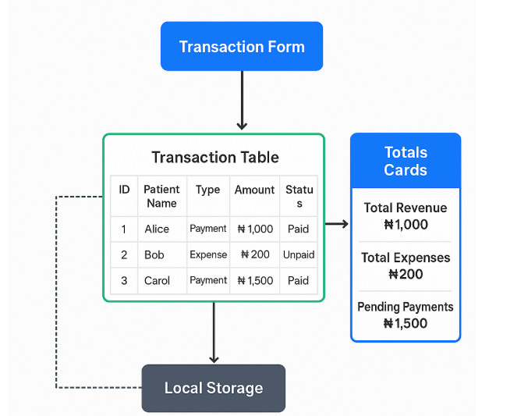

Accountant dashboard

# Accountant Dashboard - Hospital System

This HTML code creates a dashboard interface for hospital accountants to manage financial transactions. Here's a breakdown of its components:

## Structure Overview

1. **Top Navigation Bar**
- Displays "Accountant Dashboard" title
- Contains navigation buttons to different sections (Users, Account, Admin)

2. **Summary Cards**
- Three cards showing key financial metrics:
- Total Revenue (₦1,200,000)
- Total Expenses (₦850,000)
- Pending Payments (₦120,000)

3. **Tab System**
- Two tabs to switch between views:
- "View Transactions" (default active)
- "Add Transaction"

## Main Features

### View Transactions Tab
- Displays a table of financial transactions with columns:
- ID, Patient, Type (Payment/Expense), Amount, Date, Actions
- Each transaction has Edit and Delete buttons
- Includes:
- Search functionality (placeholder, not fully implemented)
- Export to PDF button (using browser's print function)
- Placeholder for an income vs expenses chart

### Add Transaction Tab
- Form to add new transactions with fields:
- Patient Name (text input)
- Transaction Type (dropdown: Payment/Expense)
- Amount (number input)
- Date (date picker)
- Submit button

## JavaScript Functionality

1. **Tab Switching**
- `showTab()` function handles showing/hiding tab content and highlighting active tabs

2. **Transaction Management**
- **Adding Transactions**:
- Form submission creates a new table row
- Updates the relevant total (revenue or expenses)
- Resets the form and switches back to transactions view
- **Deleting Transactions**:
- Confirmation dialog before deletion
- Updates the relevant total
- **Editing Transactions**:
- Populates form with existing data
- Adjusts totals (removes old amount)
- Switches to Add Transaction tab (where form is pre-filled)

3. **Currency Handling**
- `parseCurrency()` converts formatted strings to numbers
- `formatCurrency()` formats numbers as currency strings (₦1,000)

## Styling

The CSS provides a clean, modern interface with:
- Green color scheme (matching healthcare/accounting themes)
- Responsive card layout
- Hover effects on interactive elements
- Consistent spacing and typography
- Printable layout for PDF export

## Limitations

1. Data is not persisted (would be lost on page refresh)
2. Search functionality is not implemented
3. Chart is just a placeholder
4. No backend integration (would typically connect to a database)

This dashboard provides the frontend interface for hospital accountants to track and manage financial transactions, with basic CRUD (Create, Read, Update, Delete) operations implemented in JavaScript.

